**Visvesvaraya Technological University**

# Belagavi, Karnataka-590 018



A Mini Project Report on

**“Online Appointment Management System”**

Mini Project Report submitted in partial fulfillment of the requirement for the award of the degree

## Bachelor of Engineering in

**Information Science and Engineering**

Submitted by,

**Ashit Chuphal**

**1MJ17IS012**

Under the esteemed guidance of

**Dr. Mannar Mannan**

### Associate Professor



# M V J College of Engineering, Bengaluru-67

**Department of Information Science and Engineering**

**2019-2020**



# CERTIFICATE

Certified that the project work titled **“ONLINE APPOINTMENT MANAGEMENT SYSTEM”** is a bona fide work carried out by **ASHIT CHUPHAL(1MJ17IS012)** in partial fulfillment for the award of Bachelor of Engineering in Information Science and Engineering of the Visvesvaraya Technological University, Belagavi during the academic year 2019-20. It is certified that all corrections and suggestions indicated for Internal Assessment have been incorporated in the report. The report has been approved as it satisfies the academic requirements in respect of Project Work prescribed for the Bachelor of Engineering Degree.

**Signature of Guide Signature of HOD**

**Dr. Mannar Mannan Mrs. Sanchari Saha**

**Associate Professor Assistant Professor & HOD**

**Dept. of ISE Dept. of ISE**

**MVJCE MVJCE**

## Sl.no Examiners Signature with date

**1**

**2**

# M V J College of Engineering, Bengaluru-67

**Department of Information Science and Engineering**

## 2019-20



# DECLARATION

I, ASHIT CHUPHAL (1MJ17IS012) hereby declare that the dissertation entitled, **“ONLINE APPOINTMENT MANAGEMENT SYSTEM”** has been completed and written by me under the supervision of Dr Mannar Mannan, Associate Professor, Department of Information Science and Engineering, MVJCE, Bangalore, in partial fulfillment of the requirements for the award of the degree of Bachelor of Engineering in Information Science and Engineering, of Visvesvaraya Technological University, Belagavi. The dissertation report is original and it has not been submitted for any other degree in any university.

|  |  |
| --- | --- |
| Date: | ASHIT CHUPHAL |
| Place: | (1MJ17IS012) |

## ACKNOWLEDGEMENT

The satisfaction that accompanies the successful completion of this project report would be incomplete without the mention of people who made it possible, without whose constant guidance and encouragement, would have made efforts go in vain. I consider ourselves privileged to express gratitude and respect towards all those who guided us through the completion of this project.

I, acknowledge our beloved Principal **Dr. Nagaraj Sitaram**, who has always been and shall always be a source of motivation to us.

I am grateful to **Mrs. Sanchari Saha**, Ass Professor and HOD, Information Science and Engineering, for giving the support and encouragement that was necessary for the completion of this project. In this context, I would also like to thank all the other staff members, both teaching and non-teaching, who have extended their timely help and eased our task.

I, also convey thanks to my project guide **Dr. Mannar Mannan**, Associate Professor, Department of Information Science and Engineering, for providing encouragement, constant support and guidance which was of great help to complete this project work successfully.

I would like to express my heart-felt gratitude to my parents and friends for their continued moral and material support throughout the course and in helping me finalize the project report.

**ASHIT CHUPHAL**

# ABSTRACT

The Online Appointment Management system is a computerized management system. This system keeps the records of the appointments which is being registered by the customer and verified by the administrator.

This project has GUI based software that will help in storing, updating and retrieving the information through various user-friendly menu-driven modules.

The project “Online Appointment Management System” is aimed to develop to maintain the daily appointments of customers with different doctors and clinics. It helps the customer to think wisely to visit the doctor of his choice.

|  |  |  |  |
| --- | --- | --- | --- |
| 1  2  3  4              **Sl. No.**  1      2    3        4 | **TABLE OF CONTENTS**  Acknowledgement  Abstract  Table of Contents  List of Figures            **Title**  Introduction  1.1 Problem statement    Analysis and System Requirements  2.1 Proposed Solution  2.2 System Configuration  System Design and Modelling  3.1 Preliminary Design  3.2 ER Diagram  3.3 Schema Diagram  3.4 Database Relation  Implementation  4.1 Flow Chart and Data Flow Model  4.2 Module 1-Backend  4.3 Module 2-Frontend  4.4 Source code |  | I  II  III  IV        **Page No.**  1  1  3  3  4  5  5  8  9  11  14  14  15  16  18 |

iii

|  |  |  |  |  |
| --- | --- | --- | --- | --- |
| 5    6  7    8 | Screenshots  Figure 1 Home Page 1  Figure 2 Login Page  Figure 3 Sign Up Page  Figure 4 Admin Login Page  Figure 5 Admin Main Page  Figure 6 Add new Doctor Page  Figure 7 Doctor’s Schedule Page  Figure 8 Doctor’s Details Page  Figure 9 Add new Clinic Page  Figure 10 Assign Doctor to Clinic Page  Figure 11 Total Clinic’s Page  Figure 12 Customer’s Page  Testing  6.1 Introduction to Testing  Conclusion  Bibliography  iv |  |  | 23  24  24  25  25  26  26  27  27  28  28  29  30    32    32 |

|  |
| --- |
| **LIST OF FIGURES**      **FIG. NO. TITLE PAGE NO.**    Figure 1 Home Page 1 23  Figure 2 Login Page 24  Figure 3 Sign Up Page 24  Figure 4 Admin Login Page 25  Figure 5 Admin Main Page 25  Figure 6 Add New Doctor Page 26  Figure 7 Doctor’s Schedule Page 26  Figure 8 Doctor’s details Page 27  Figure 9 Add new clinic Page 27  Figure 10 Assign Doctor to Clinic Page 28  Figure 11 Total Clinics Page 28  Figure 12 Customer’s Page 29      v |

**Chapter 1**

## INTRODUCTION

### Preamble

Online Appointment Management System is a computerized management system. This system keeps the

records of the Online Appointment being booked in this organization. The proposed system will keep a track of different appointment details including the doctors and clinic details. This project has GUI based software that will help in storing, updating and retrieving the information through various user-friendly menu-driven modules. The project “Online Appointment Management System” is aimed to develop to maintain the day-to-day appointments. Main objective of this project is to provide appointments and clinic details to customers. This software application will help admin to handle customer information, doctor details and clinic details. Detailed explanation about modules and design are provided in project documentation. The existing system is a manually maintained system. All the appointment records are to be maintained for the details of each customer, doctor details, appointment registration, etc. All these details are entered and retrieved manually, because of this there are many disadvantages like:

1. - Time Consuming

1. - Exhaustive and inefficient updating process

1. - Inaccuracy of data and room for human error in manual entry

For avoiding this we introduced or proposed a new system in proposed system the computerized version of the existing system which provides easy and quick access over the data.

### 1.1 PROBLEM STATEMENT

In the existing manual system, a lot of time is spent in communicating and sending the information across different branches and their independent website. The current world still works on the traditional, orthodox system of written entries of the registration and manually submitting all the information of booking oppointment

which is tedious and inefficient. There are more chances for the humans involved in the system to error, and this old-fashioned method also takes a long time to execute manually, even after not considering the high chances of mistakes. Also, due to the constant changing of the day to day life, it will lead to proportionate changes to the cost and appointments, which makes updating them dynamically everywhere tough.

All the old techniques and modus-operandi prove to be an inefficient and mammoth task, and we need to

overcome this.

There is a need for an integrated automated system, which has some centralized control over the entire

process. Conventional System makes use of huge amounts of paper for recording transactions. The existing system is a manually maintained system. All the appointment records are to be maintained for the details of each customers, doctor's details, clinic details and appointments details etc. All these details are entered and retrieved

manually.

**Disadvantages:**

1. Time consuming.

1. Inaccuracy of data.

1. More prone to errors when being manipulated manually

**Implementation using different user types:**

**1. Admin**

**2. User**

* **ADMIN MODULE:**

This module provides administrator related functionalities. Administrator can view the registered customers and their details, doctors available, appointment details along with the current approval status. In this module admin has to verify all the details of the particular customer and then he either approve or reject the appointment of the doctor that the customer is requesting. Admin will give the responses to customer based on submitted details always checking the doctor details and authenticity of the details.

This module also requires the admin logged in to keep all the customer information confidential and not disclose it to any other third party, not compromising the data to unauthorized access.

* **USER MODULE:**

This module is about users of this portal. By using this module user, i.e., the customer can give their details along with all the necessary details. User must be registered with the system. Customer booking details must be kept confidential after that he/she will give their personal details through the website. By using this login id, the customer just needs to book appointments giving all the details of the appointment such as username, city, clinic, doctor and date of visit. Then the customer has to wait until any progress is updated .After the booking the customer can check the booking status for the respective doctor.

**Chapter 2**

## ANALYSIS AND SYSTEM REQUIREMENTS

### 2.1 PROPOSED SOLUTION

Proposed system is a computerized version of the existing system which provides easy and quick access

over the data keeping records of the land details so that the verification and registering the details is effective and efficient.

**Advantages:**

1. Storing customer details and appointment details properly

1. Maintains accuracy of data and reduces error

**OBJECTIVES**

The limited time and resources have restricted us to incorporate, in this project, only the main activities that are performed in a ‘Online Appointment Management System’, but utmost care has been taken to make the system efficient and user friendly.

“Online Appointment Management System” has been designed to computerized the functions for entering

and retrieving the following details:

1. Booking:- Username, Name, Gender, CID, DID, DOV, Timestamp, Status.
2. Clinic:- CID, Address, Name, Town, City, Contact.
3. Doctor:- DID, Name, Gender, DOB, Experience, Specialization, Contact, Address, Username, Password, Region.
4. Doctor Available:- CID, DID, Day, Start time, End time.
5. Patients:- Name, Gender, DOB, Phone, Username, Password, Email.
6. Deleted Doctors:- DID, Name, Gender, DOB, Experience, Specialization, Contact, Address, Username, Password, Region.

### 2.2 SYSTEM CONFIGURATION

**H/W System Configuration:**

* Processor - Pentium –III
* Speed - 1.1 GHz
* RAM - 256 MB (min)
* Hard Disk - 20 GB (min)
* Floppy Drive - 1.44 MB
* Key Board - Standard Windows Keyboard
* Mouse - Two or Three Button Mouse ➢ Monitor - SVGA

**S/W System Configuration: -**

* Operating System - Windows95/98/2000/XP/8.1/10
* Application Server - Apache
* Front End - HTML, CSS
* Back End - PHP
* Database Connectivity - MySQL

* Connecting front end and back end - PHP

**Chapter 3**

## SYSTEM DESIGN AND MODELLING

**3.1 PRELIMINARY DESIGN:**

 **ENTITY RELATIONSHIP DIAGRAM (ERD)**

**Entity – Relationship Diagram:** This depicts relationship between data objects. The attribute of each data objects noted in the entity- relationship diagram can be described using a data object description.

Data flow diagram serves two purposes:

1. To provide an indication of how data are transformed as they move through the system.
2. To depict the functions that transformation the data flow.

**The basic components of entity relationship diagram/model are listed and defined below: Data Objects:** A data object is a representation of almost any composite information that must be understood by the software. By composite information, we mean something that has a number of different properties or attributes. A data object encapsulates data only there is no reference within a data object to operations that act on the data.

**Attributes:** Attributes define the properties of a data object and take on one of three different characteristics

They can be used to:

* + Name an instance of data object.
  + Describe the instance.
  + Make reference to another instance in other table.

**Relationships:** Data objects are connected to one another in a variety of different ways. We can define a set of object relationship pairs that define the relevant relationships.

* **CARDINALITY AND MODALITY:**

**Cardinality:**

The data model must be capable of representing the number of occurrences of objects in a given relationship. The cardinality of an object relationship pair is

* + **One-T0-One (1:1):** An occurrence of object ‘A’ can relate to one and only one occurrence of object ‘B’ and vice versa.
  + **One-To-Many (1: N):** One occurrence of object ‘A’ can relate to one or may occurrences of object ‘B’ but an occurrence of object ‘B’ can relate to only one occurrence of object ‘A’**.**
  + **Many-To-Many (M: N):** An occurrence of ‘B’ and an occurrence of ‘B’ can relate to one or many occurrences of

‘A’.

 **Modality:**

The modality of a relationship is zero if there is no explicit need for the relationship to occur or the relationship is optional. The Modality is one if the occurrence of the relationship is mandatory.

The object relationship pair can be represented graphically using the Entity Relationship Diagrams.

A set of primary components are identified for the Entity Relationship Diagram,

1. Attributes,
2. Relationships and
3. Various Type Indicators.

The primary purpose of the Entity Relationship Diagram is to represent data objects and their relationships.

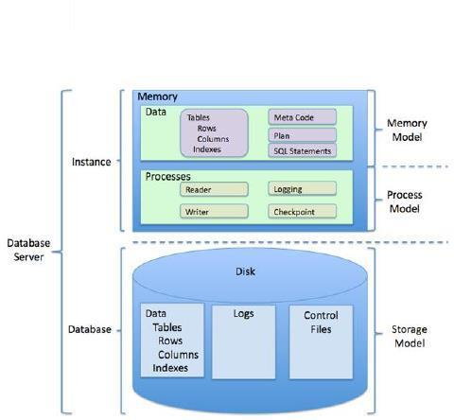

**Fig 3.1: Relational DBMS diagram (structure used in this project)**

**3.2 ER DIAGRAM:**

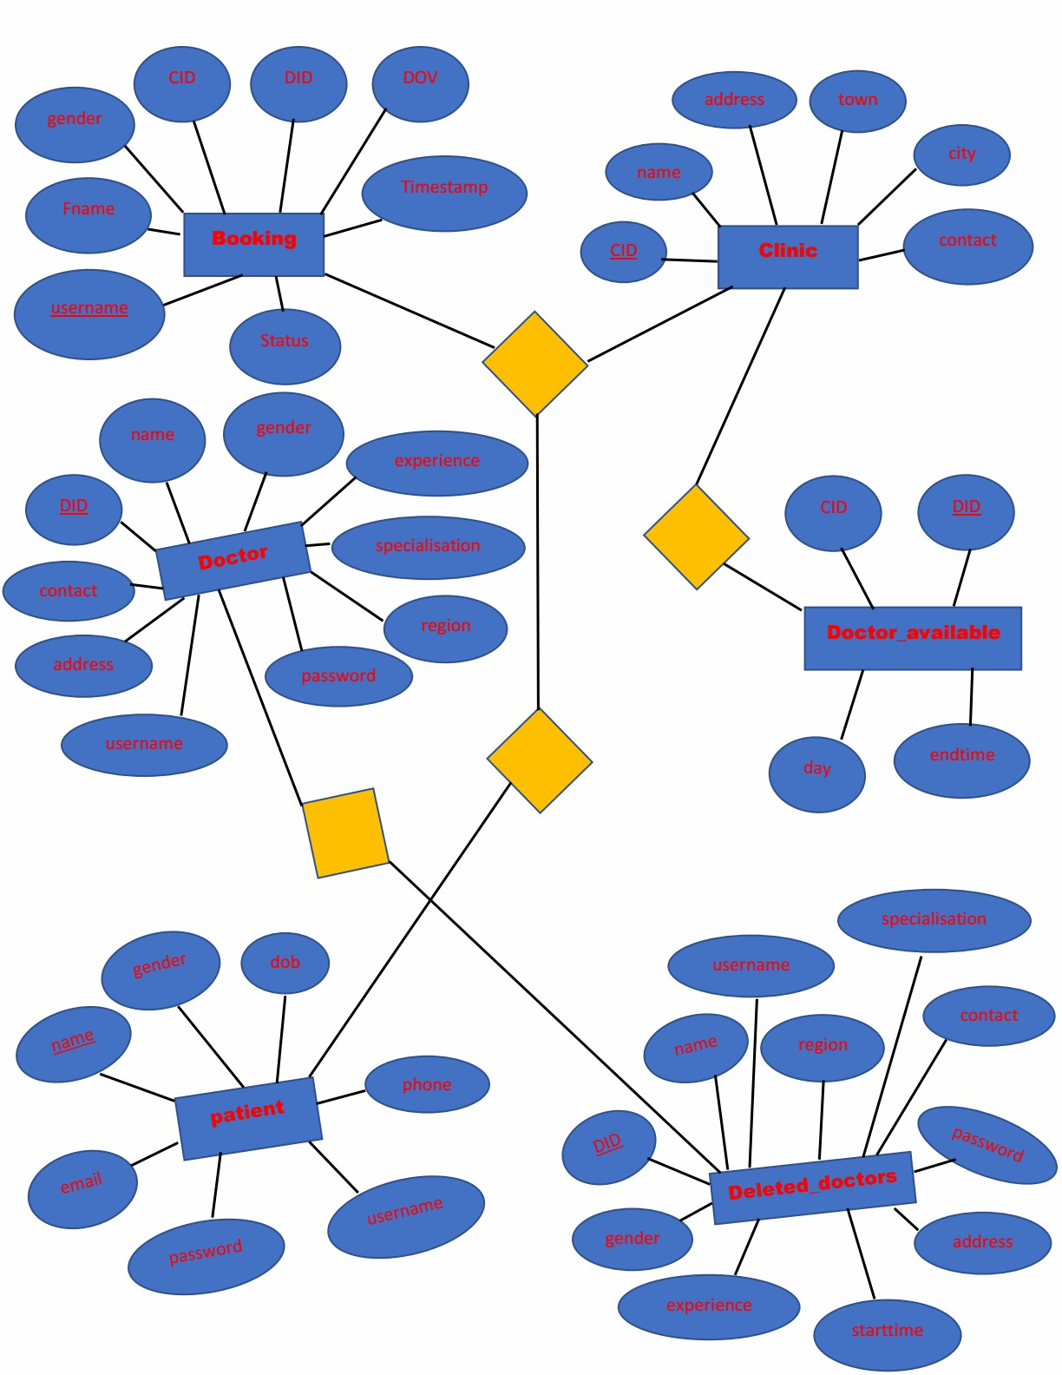

**Fig 3.2: Entity Relationship Diagram**

### 3.3 SCHEMA DIAGRAM:

**Booking**:

|  |  |  |  |  |  |  |  |
| --- | --- | --- | --- | --- | --- | --- | --- |
| Username | Fname | Gender | CID | DID | DOV | Timestamp | Status |

**Clinic**:

|  |  |  |  |  |  |
| --- | --- | --- | --- | --- | --- |
| CID | Name | Address | Town | City | Contact |

**Doctor**:

|  |  |  |  |  |  |  |  |
| --- | --- | --- | --- | --- | --- | --- | --- |
| DID | Name | Gender | DOB | Experience | Specialisation | contact | Address |

|  |  |  |
| --- | --- | --- |
| Username | Password | Region |

**Doctor_available**:

|  |  |  |  |  |
| --- | --- | --- | --- | --- |
| CID | DID | Day | Starttime | Endtime |

**Patient**:

|  |  |  |  |  |  |  |
| --- | --- | --- | --- | --- | --- | --- |
| Name | Gender | DOB | Phone | Username | Password | Email |

**Deleted_doctors**:

|  |  |  |  |  |  |  |  |
| --- | --- | --- | --- | --- | --- | --- | --- |
| DID | Name | Gender | DOB | Experience | Specialisation | contact | Address |

|  |  |  |
| --- | --- | --- |
| Username | Password | Region |

**Fig 3.3: Schema Diagram**

### 3.4 DATABASE RELATIONS

**Online Appointment Management System** consists of six tables. It is used by a Customer and admin to store and retrieve details regarding doctors, clinics, bookings.

The database uses the following tables for maintaining the details:

* Booking
* Clinic
* Doctor
* Doctor Available
* Patients
* Deleted Doctors

The description of the tables is as follows:

Table 3.1 **Booking:** This table consists of details of the appointments

|  |  |  |  |  |
| --- | --- | --- | --- | --- |
| **COLUMN NAME** | **DATATYPE**  **SIZE** | **&** | **CONSTRAINTS** | **DESCRIPTION** |
| Username | Varchar (30) |  | Primary key | Username of customer |
| Fname | Varchar (30) |  | Not Null | Name of the customer |
| Gender | Varchar (10) |  | Not Null | Gender of customer |
| CID | Int (11) |  | Not Null | Clinic ID |
| DID | Int (11) |  | Not Null | Doctor ID |
| DOV | Date |  | Not Null | Date of Visit |
| Timestamp | Datetime |  | Not Null | Date and time the booking is done |
| Status | Varchar (50) |  | Not Null | Status of appointment |

11

Table 3.2 **Clinic:** This table consists of the clinic details.

|  |  |  |  |  |
| --- | --- | --- | --- | --- |
| **COLUMN NAME** | **DATATYPE**  **SIZE** | **&** | **CONSTRAINTS** | **DESCRIPTION** |
| CID | Int (11) |  | Primary Key | The ID accepts the integer which is used to identify the clinic. |
| Name | Varchar (30) |  | Not Null | Name of the clinic |
| Address | Varchar (30) |  | Not Null | Address of the clinic |
| Town | Varchar (20) |  | Not Null | Town where the clinic is located |
| City | Varchar (20) |  | Not Null | City where the clinic is located |
| Contact | Varchar (10) |  | Not Null | Contact of the clinic |

Table 3.5 **Doctor:** This table consists of the doctor details

|  |  |  |  |  |
| --- | --- | --- | --- | --- |
| **COLUMN NAME** | **DATATYPE**  **SIZE** | **&** | **CONSTRAINTS** | **DESCRIPTION** |
| DID | Int (11) |  | Primary Key | The ID accepts the integer which is used to identify the doctor. |
| Name | Varchar (30) |  | Not Null | Name of the doctor |
| Gender | Varchar (10) |  | Not Null | Gender of the doctor |
| DOB | Date |  | Not Null | Doctor’s Date of Birth |
| Experience | Varchar (30) |  | Not Null | Doctor’s working experience in years |
| Specialisation | Varchar (30) |  | Not Null | An expert or specialist of doctor |
| Contact | Varchar (10) |  | Not Null | Doctor contact details |
| Address | Varchar (40) |  | Not Null | Doctors address or home resident |
| Username | Varchar (30) |  | Not Null | Username of doctor |
| Password | Varchar (20) |  | Not Null | Doctors password |
| Region | Varchar (20) |  | Not Null | Doctor resident city |

Table 3.4 **Doctor Available:** Table consists of the doctors availability in clinic

|  |  |  |  |
| --- | --- | --- | --- |
| **COLOUMN NAME** | **DATATYPE & SIZE** | **CONSTRAINTS** | **DESCRIPTION** |
| CID | Int (11) | Not Null | The id accepts the integer which is used to identify the clinic |
| DID | Int (11) | Primary key | The id accepts the integer which is used to identify the doctor |
| Day | Varchar (20) | Not Null | The day doctor is available in the clinic |
| Start time | Time | Not Null | Clinic opening time |
| End time | Time | Not Null | Clinic closing time |

Table 3.5 **Patients:** This table consists of the details about the customer.

|  |  |  |  |  |
| --- | --- | --- | --- | --- |
| **COLUMN NAME** | **DATATYPE**  **SIZE** | **&** | **CONSTRAINTS** | **DESCRIPTION** |
| Name | Varchar (30) |  | Primary Key | Name of the customer |
| Gender | Varchar (10) |  | Not Null | Gender of the customer. |
| DOB | Varchar (50) |  | Not Null | Customer’s Date of Birth |
| Phone | Varchar (10) |  | Not Null | Phone number of the customer. |
| Username | Varchar (20) |  | Unique | Username of the customer. |
| Password | Varchar (30) |  | Not Null | Customer’s secured password used while logging in. |
| Email | Varchar (30) |  | Not Null | Customer’s email used to send mails regarding appointments |

Table 3.6 **Deleted Doctors:** This table consists of the doctor details deleted by admin(Trigger).

|  |  |  |  |  |
| --- | --- | --- | --- | --- |
| **COLUMN NAME** | **DATATYPE**  **SIZE** | **&** | **CONSTRAINTS** | **DESCRIPTION** |
| DID | Int (11) |  | Primary Key | The ID accepts the integer which is used to identify the doctor. |
| Name | Varchar (30) |  | Not Null | Name of the doctor |
| Gender | Varchar (10) |  | Not Null | Gender of the doctor |
| DOB | Date |  | Not Null | Doctor’s Date of Birth |
| Experience | Varchar (30) |  | Not Null | Doctor’s working experience in years |
| Specialisation | Varchar (30) |  | Not Null | An expert or specialist of doctor |
| Contact | Varchar (10) |  | Not Null | Doctor contact details |
| Address | Varchar (40) |  | Not Null | Doctors address or home resident |
| Username | Varchar (30) |  | Not Null | Username of doctor |

### 3.5 Normalization

* Process for evaluating and correcting table structures to minimize data redundancies
* Reduces data anomalies
* Works through a series of stages called normal forms:
* First normal form (1NF)
* Second normal form (2NF)

* Third normal form (3NF)

#### 1st NF

Database is in first normal form, if it satisfies the following conditions

1. Contains only atomic values. 2. There are no repeating groups.

#### 2nd NF

A relation schema R is in second normal form, if every non-primary attribute A is fully functionally Dependant on Primary key of R

1. It is in 1NF
2. All non-key attributes are fully functionally dependant on primary key.

#### 3rd NF

1. It is in 2NF

2.there are no transitive functional dependencies

The above tables satisfy all three normal forms

**Chapter 4**

## IMPLEMENTATION

### 4.1 Flow Chart and Data Flow Model

A flowchart is a type of diagram that represents an algorithm, workflow or process, showing the steps as boxes of various kinds, and their order by connecting them with arrows. This diagrammatic representation illustrates a solution model to a given problem. Flowcharts are used in analyzing, designing, documenting or managing a process or program in various fields.

Flowcharts are used in designing and documenting simple processes or programs. Like other types of diagrams, they help visualize what is going on and thereby help understand a process, and perhaps also find flaws, bottlenecks, and other less-obvious features within it. There are many different types of flowcharts, and each type has its own repertoire of boxes and notational conventions. The two most common types of boxes in a flowchart are:

• a processing step, usually called *activity*, and denoted as a rectangular box decision, usually denoted as and

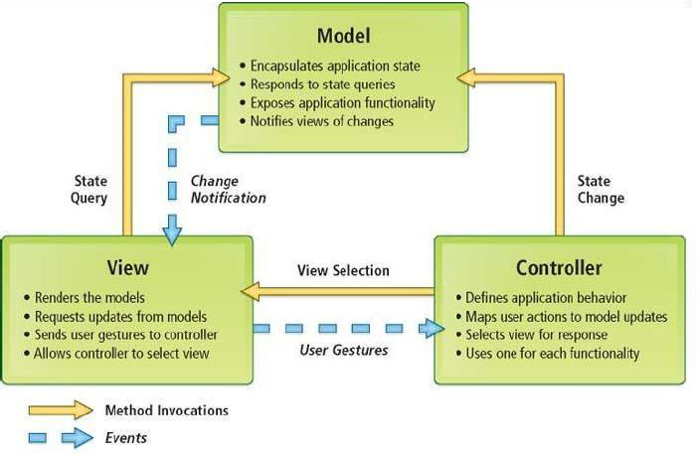

**Fig4.1: Data flow model**

### 4.2 MODULE 1 – BACKEND



* **PHPMYADMIN**

PhpMyAdmin is used for connecting the database to the apache server.

**phpMyAdmin** is a [free and open source](https://en.wikipedia.org/wiki/Free_and_open_source) administration tool for [MySQL a](https://en.wikipedia.org/wiki/MySQL)nd [MariaDB. A](https://en.wikipedia.org/wiki/MariaDB)s a portable [web application](https://en.wikipedia.org/wiki/Web_application) written primarily in [PHP,](https://en.wikipedia.org/wiki/PHP) it is currently one of the most popular MySQL administration tools, especially for [web hosting services.](https://en.wikipedia.org/wiki/Web_hosting_service)

It has the following features:

* Intuitive web interface
* Support for most MySQL features
* Import data from CSV and SQL
* Export data to various formats: CSV, SQL, XML, PDF, ISO/IEC 26300 - OpenDocument Text and

Spreadsheet, Word, Excel, LATEX and others

* Administering multiple servers
* Creating PDF graphics of your database layout
* **MY SQL**

We have used, in this project , MySQL which is an [open-source](https://en.wikipedia.org/wiki/Open-source) [relational database management system.](https://en.wikipedia.org/wiki/Relational_database_management_system) MySQL is a central component of the LAMP open-source web application software stack (and other "AMP" stacks). LAMP is an acronym for "Linux, Apache, MySQL, Perl/PHP/Python". Applications that use the MySQL database include: TYPO3, MODx, Joomla, WordPress, phpBB, MyBB, and Drupal. MySQL is also used in many high-profile, large-scale websites, including Google (though not for searches), Facebook, Twitter, Flickr, and YouTube.

### 4.3 MODULE 2 – FRONTEND

We have used the following front-end languages:

• **HTML**

**Hypertext Mark-up Language** (**HTML**) is the standard [mark-up language f](https://en.wikipedia.org/wiki/Markup_language)or creating [web pages a](https://en.wikipedia.org/wiki/Web_page)nd [web applications. W](https://en.wikipedia.org/wiki/Web_application)ith [Cascading Style Sheets (](https://en.wikipedia.org/wiki/Cascading_Style_Sheets)CSS) and [JavaScript i](https://en.wikipedia.org/wiki/JavaScript)t forms a triad of cornerstone technologies for the [World Wide Web.](https://en.wikipedia.org/wiki/World_Wide_Web) [Web browsers r](https://en.wikipedia.org/wiki/Web_browser)eceive HTML documents from a [web server o](https://en.wikipedia.org/wiki/Web_server)r from local storage and render them into multimedia web pages. HTML describes the structure of a web pag[e semantically](https://en.wikipedia.org/wiki/Semantic_Web) and originally included cues for the appearance of the document.

[HTML elements a](https://en.wikipedia.org/wiki/HTML_element)re the building blocks of HTML pages. With HTML constructs, [images a](https://en.wikipedia.org/wiki/HTML_element#Images_and_objects)nd other

objects, such as forms, may be embedded into the rendered page. It provides a means to create [structured documents b](https://en.wikipedia.org/wiki/Structured_document)y denoting structural [semantics f](https://en.wikipedia.org/wiki/Semantics)or text such as headings, paragraphs, lists, [links,](https://en.wikipedia.org/wiki/Hyperlink) quotes and other

items. HTML

|  |  |  |  |  |
| --- | --- | --- | --- | --- |
| <img /> | and | <input /> | introduce content into the page directly. Others such as | <p>...</p> |

elements are

delineated by *tags*, written using [angle brackets. T](https://en.wikipedia.org/wiki/Bracket#Angle_brackets)ags such as surround and provide information about document text and may include other tags as sub-elements. Browsers do not display the HTML tags, but use them to interpret the content of the page.

HTML can embed programs written in [a scripting language s](https://en.wikipedia.org/wiki/Scripting_language)uch as [JavaScript w](https://en.wikipedia.org/wiki/JavaScript)hich affect the

behavior and content of web pages. Inclusion of CSS defines the look and layout of content.

* **CSS**

Cascading Style Sheets (CSS) is a style sheet language used for describing the presentation of a document written in a mark-up language. Although most often used to set the visual style of web pages and user interfaces written in HTML and XHTML, the language can be applied to any XML document, including plain XML, SVG and XUL, and is applicable to rendering in speech, or on other media. Along with HTML and JavaScript, CSS is a cornerstone technology used by most websites to create visually engaging webpages, user interfaces for web applications, and user interfaces for many mobile applications

CSS is designed primarily to enable the separation of presentation and content, including aspects such as the layout, colors, and fonts. This separation can improve content accessibility, provide more flexibility and control in the specification of presentation characteristics, enable multiple HTML pages to share formatting by specifying the relevant CSS in a separate .css file, and reduce complexity and repetition in the structural content.

Changes to the [graphic design o](https://en.wikipedia.org/wiki/Graphic_design)f a document (or hundreds of documents) can be applied quickly and easily, by editing a few lines in the CSS file they use, rather than by changing mark-up in the documents.

* **PHP**

PHP is a server-side scripting language designed primarily for web development but also used as a general- purpose programming language. Originally created by Rasmus Lerdorf in 1994, the PHP reference implementation is now produced by The PHP Development Team. PHP originally stood for Personal Home Page, but it now stands for the recursive acronym PHP: Hypertext Pre-processor.

PHP code may be embedded into HTML or HTML5 mark-up, or it can be used in combination with various web template systems, web content management systems and web frameworks. PHP code is usually processed by a PHP interpreter implemented as a module in the web server or as a Common Gateway Interface (CGI) executable. The web server software combines the results of the interpreted and executed PHP code, which may be any type of data, including images, with the generated web page. PHP code may also be executed with a

command-line interface (CLI) and can be used to implement standalone graphical applications.

**4.4 SOURCE CODE:**

**Home Page:-**

<html>

<body style="background-image: url(Images/Pic5.jpg);">

    <link rel="stylesheet" href="main.css">

        <div class="header">

            <ul>

                <li style="float: left; border-right: none;"> <a href="Home.php" class="logo"> <img src="Images/Pic9.png" width="70px" height="60px"> <strong> WeCare </strong> Online Apppointment System </a> </li>

            </ul>

        </div>

        <div class="center">

            <h2 style="text-align: right;"> WeCare</h2><br>

            <p style="text-align: right; font-size:40px; font-family: cursive; color: black;">Consult Now </p><br>

            <button onclick="document.getElementById('id01').style.display='block'" style="position: absolute;top: 60%;left:90%;">LOGIN</button>

            <button onclick="window.location.href='Signup.php'" style="position: absolute;top: 70%;left:90%;">SIGNUP</button>

        </div>

        <div class="footer">

            <ul style="position: absolute;top:90%;background-color:black;">

                <li> <a href="AdminLogin.php">Admin Login </a> </li>

            </ul>

        </div>

<div id="id01" class="modal">

    <form class="modal-content animate" method="POST" action="InsertLogin.php">

        <div class="imgcontainer">

            <span style="float:left";><h2>Log In</h2></span>

            <span onclick="document.getElementById('id01').style.display='none'" class="close" title="Close Modal">&times;</span>

        </div>

        <div class="container">

            <label><b>Username</label></b></label>

            <input type="text" placeholder="Enter your Username" name="uname" required   >

            <label><b>Password</b></label>

            <input type="password" placeholder="Enter your Password" name="psw" required>

            <button type="submit" name="login">LOGIN</button>

            <input type="checkbox" checked="checked"> Remember my login

        </div>

        <div class="container" style="background-color:white">

            <button type="button" onclick="document.getElementById('id01').style.display='none'" class="cancelbtn">Cancel</button>

            <button type="submit" onclick="window.location.href='Signup.php'" name="signup" style="float: left">Sign Up</button>

        </div>

    </form>

</div>

</body>

</html>

-- **Database: `appointment`**

--

DELIMITER $$

--

-- Procedures

--

CREATE DEFINER=`root`@`localhost` PROCEDURE `Src` () NO SQL

SELECT *FROM patient$$

DELIMITER ;

-- --------------------------------------------------------

--

-- Table structure for table `booking`

--

CREATE TABLE `booking` (

`username` varchar(30) NOT NULL,

`Fname` varchar(30) NOT NULL,

`gender` varchar(10) NOT NULL,

`CID` int(11) NOT NULL,

`DID` int(11) NOT NULL,

`DOV` date NOT NULL,

`Timestamp` datetime NOT NULL,

`Status` varchar(50) NOT NULL

) ENGINE=InnoDB DEFAULT CHARSET=latin1;

--

-- Dumping data for table `booking`

--

-- Table structure for table `clinic`

--

CREATE TABLE `clinic` (

`CID` int(11) NOT NULL,

`name` varchar(30) NOT NULL,

`address` varchar(30) NOT NULL,

`town` varchar(20) NOT NULL,

`city` varchar(20) NOT NULL,

`contact` varchar(10) NOT NULL

) ENGINE=InnoDB DEFAULT CHARSET=latin1;

--

-- Dumping data for table `clinic`

--

-- Table structure for table `deleted_doctors`

--

CREATE TABLE `deleted_doctors` (

`DID` int(11) NOT NULL,

`name` varchar(30) NOT NULL,

`gender` varchar(10) NOT NULL,

`dob` date NOT NULL,

`experience` varchar(30) NOT NULL COMMENT '(years)',

`specialisation` varchar(30) NOT NULL,

`contact` varchar(10) NOT NULL,

`address` varchar(40) NOT NULL,

`username` varchar(30) NOT NULL,

`password` varchar(20) NOT NULL,

`region` varchar(20) NOT NULL

) ENGINE=InnoDB DEFAULT CHARSET=latin1;

--

-- Dumping data for table `deleted_doctors`

--

-- Table structure for table `doctor`

--

CREATE TABLE `doctor` (

`DID` int(11) NOT NULL,

`name` varchar(30) NOT NULL,

`gender` varchar(10) NOT NULL,

`dob` date NOT NULL,

`experience` varchar(30) NOT NULL COMMENT '(years)',

`specialisation` varchar(30) NOT NULL,

`contact` varchar(10) NOT NULL,

`address` varchar(40) NOT NULL,

`username` varchar(30) NOT NULL,

`password` varchar(20) NOT NULL,

`region` varchar(20) NOT NULL

) ENGINE=InnoDB DEFAULT CHARSET=latin1;

--

-- Dumping data for table `doctor`

--

-- Triggers `doctor`

--

DELIMITER $$

CREATE TRIGGER `deletedDoc` AFTER DELETE ON `doctor` FOR EACH ROW INSERT INTO deleted_doctors(DID,name,gender,dob,experience,specialisation,contact ,address,username,password,region) VALUES (old.DID,old.name,old.gender,old.dob,old.experience,old.specialisation, old.contact,old.address,old.username,old.password,old.region)

$$

DELIMITER ;

-- --------------------------------------------------------

--

-- Table structure for table `doctor_available`

--

CREATE TABLE `doctor_available` (

`CID` int(11) NOT NULL,

`DID` int(11) NOT NULL,

`day` varchar(20) NOT NULL,

`starttime` time NOT NULL,

`endtime` time NOT NULL

) ENGINE=InnoDB DEFAULT CHARSET=latin1;

--

-- Dumping data for table `doctor_available`

--

-- Table structure for table `patient`

--

CREATE TABLE `patient` (

`name` varchar(30) NOT NULL,

`gender` varchar(10) NOT NULL,

`dob` date NOT NULL,

`phone` varchar(10) NOT NULL,

`username` varchar(20) NOT NULL,

`password` varchar(30) NOT NULL,

`email` varchar(30) NOT NULL

) ENGINE=InnoDB DEFAULT CHARSET=latin1;

--

-- Dumping data for table `patient`

-- Indexes for dumped tables

-- Indexes for table `booking`

--

ALTER TABLE `booking`

ADD PRIMARY KEY (`username`);

--

-- Indexes for table `clinic`

--

ALTER TABLE `clinic`

ADD PRIMARY KEY (`CID`);

--

-- Indexes for table `deleted_doctors`

--

ALTER TABLE `deleted_doctors`

ADD PRIMARY KEY (`DID`);

--

-- Indexes for table `doctor`

--

ALTER TABLE `doctor`

ADD PRIMARY KEY (`DID`);

--

-- Indexes for table `patient`

--

ALTER TABLE `patient`

ADD PRIMARY KEY (`name`);

COMMIT;

/*!40101 SET CHARACTER_SET_CLIENT=@OLD_CHARACTER_SET_CLIENT */;

/*!40101 SET CHARACTER_SET_RESULTS=@OLD_CHARACTER_SET_RESULTS */;

/*!40101 SET COLLATION_CONNECTION=@OLD_COLLATION_CONNECTION */;

**Chapter 5**

## SCREENSHOT

**Figure 1: Home Page**



**Figure 2: Login page**

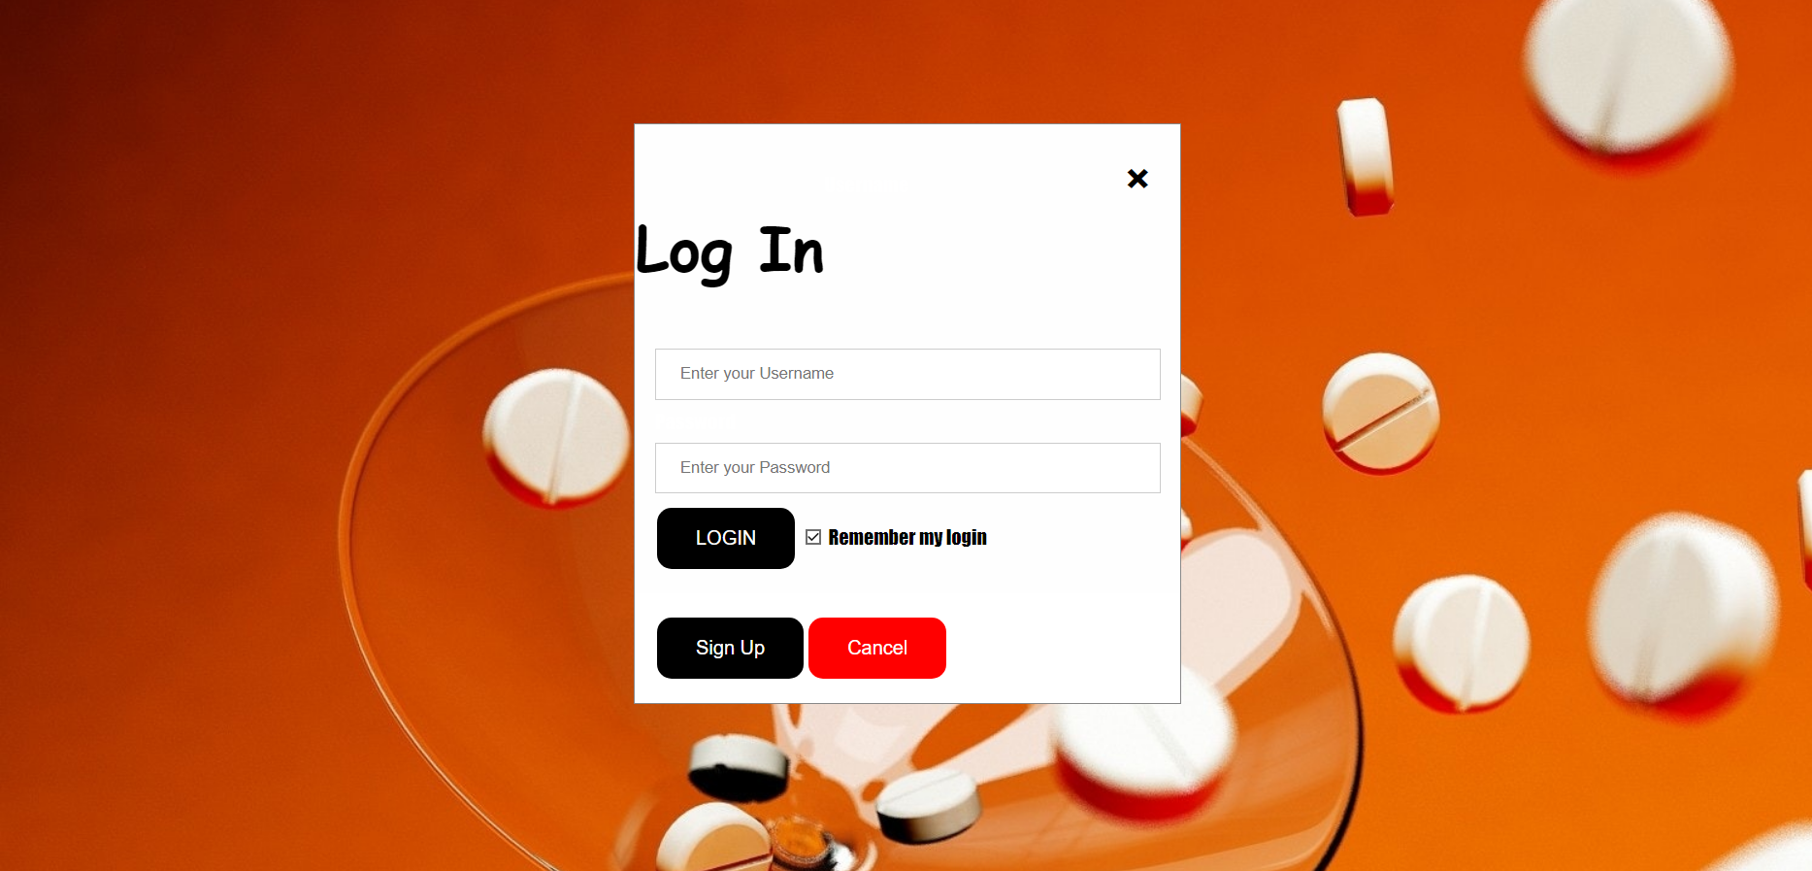

**Figure 3: Sign Up Page**

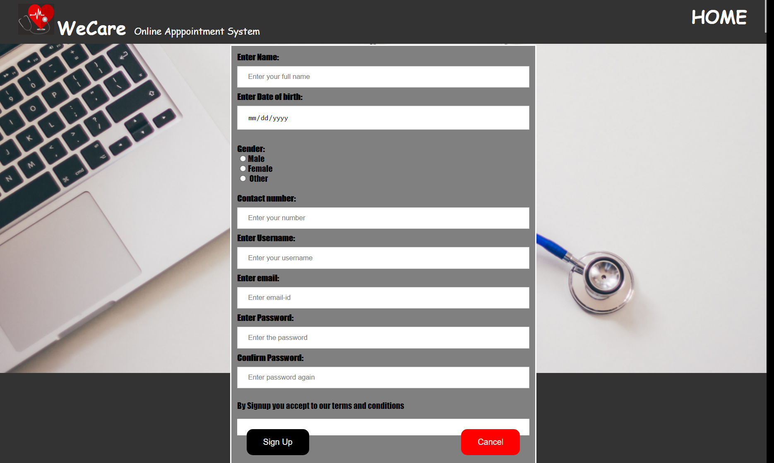

**Figure 4: Admin Login Page**

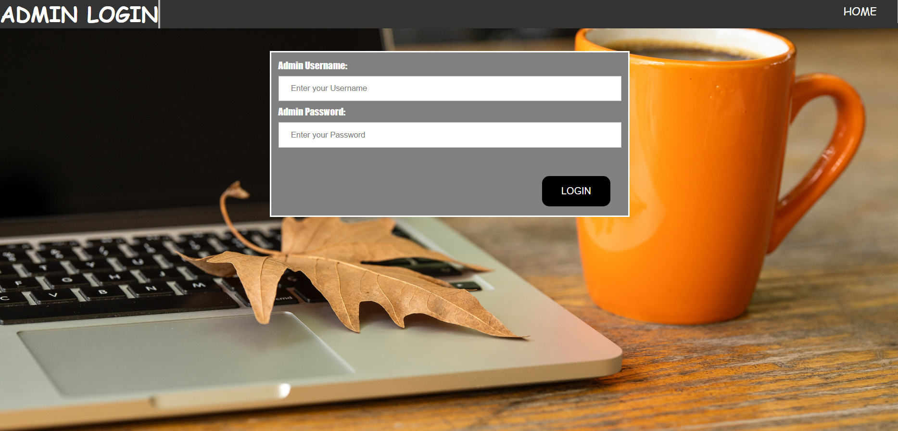

**Figure 5: Admin Main Page**



**Figure 6: Add new doctor Page**

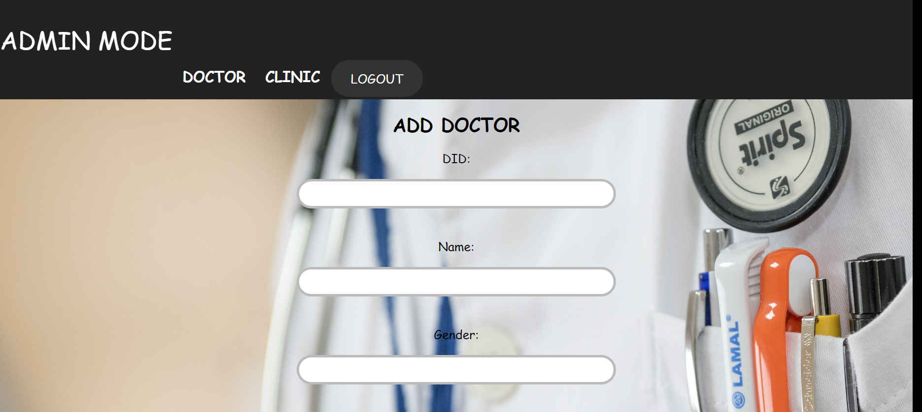

**Figure 7: Doctor’s Schedule Page**

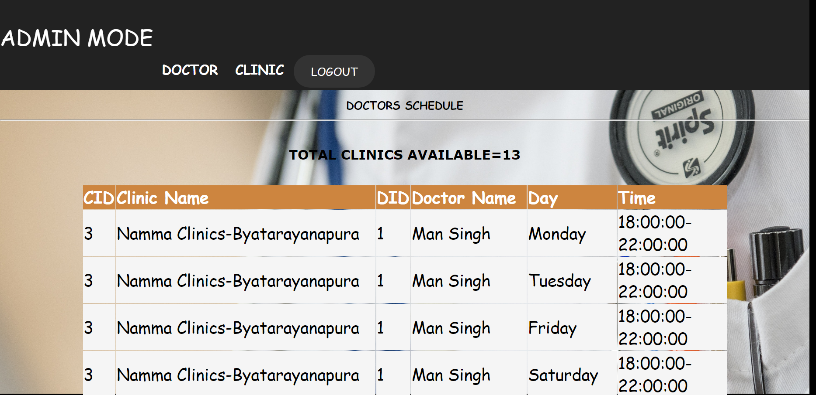

**Figure 8: Doctor’s details Page**

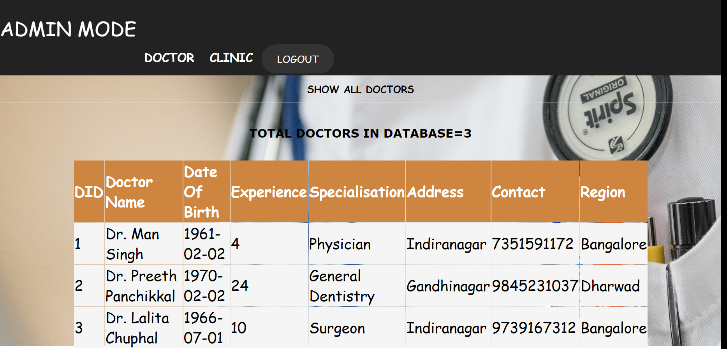

**Figure 9: Add new clinic Page**

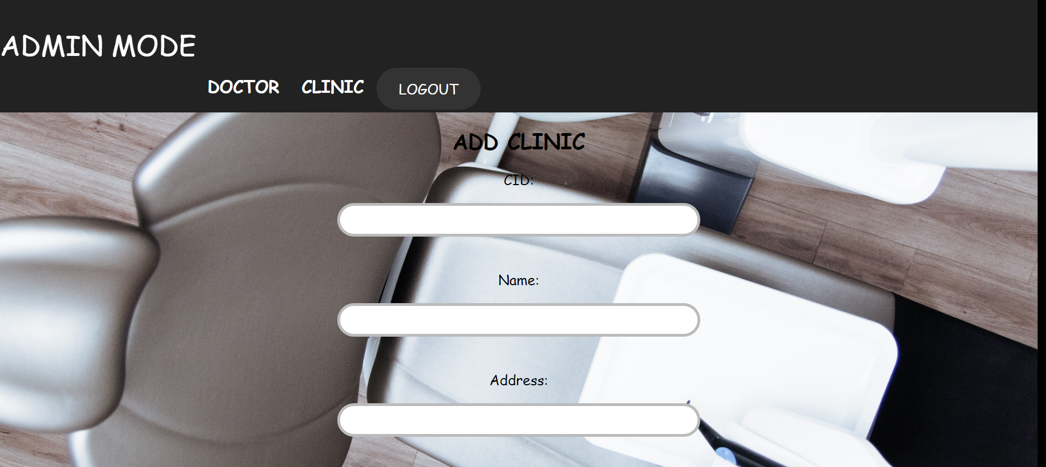

**Figure 10: Assign doctor to clinic Page**

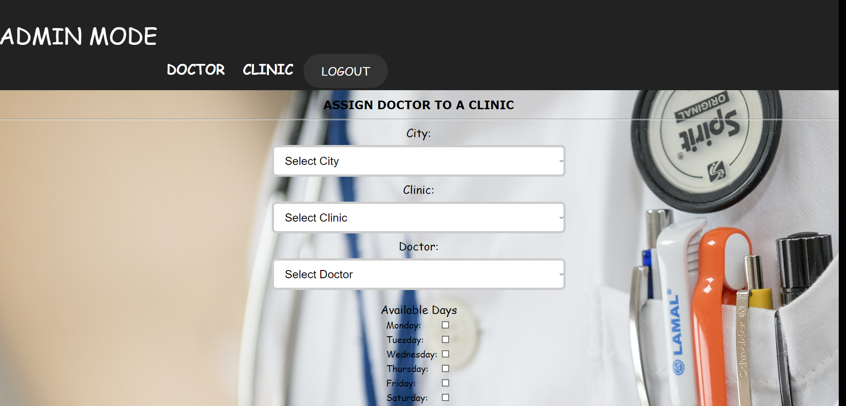

**Figure 11: Total Clinics Page**

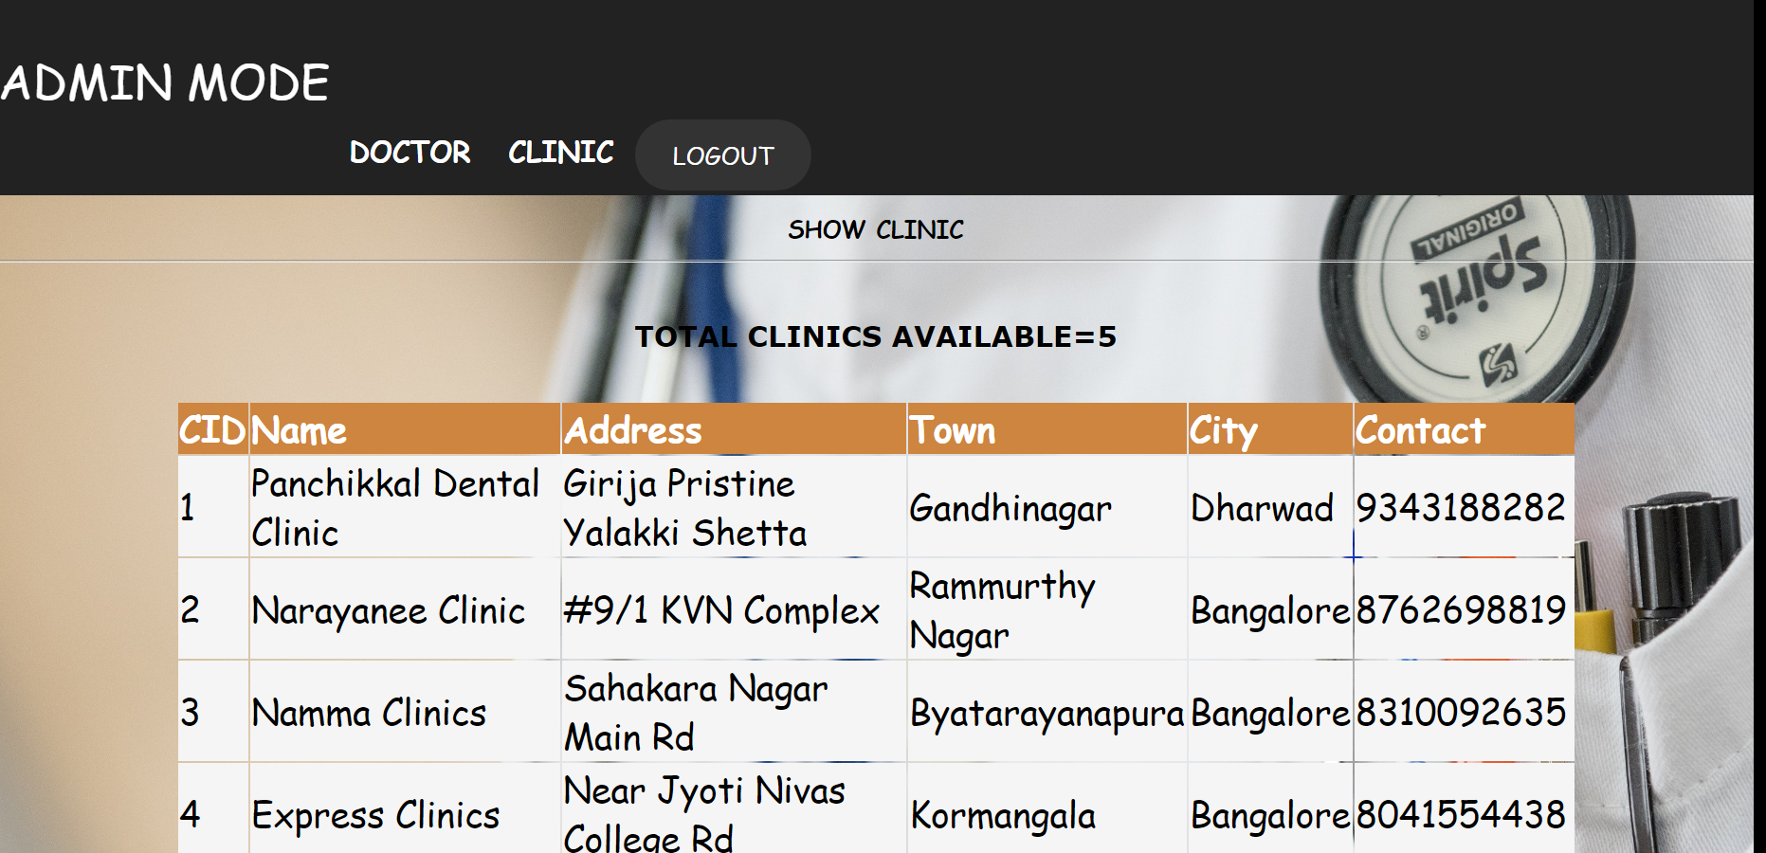

**Figure 12: Customer’s Page**

**Chapter 6**

## TESTING

### 6.1 Introduction to testing

* **SOFTWARE TESTING**

Software Testing is a critical element of software quality assurance and represents the ultimate review of specification, design and coding, Testing presents an interesting anomaly for the software engineer.

* **Testing Objectives include:**

* 1. Testing is a process of executing a program with the intent of finding an error

* 1. A good test case is one that has a probability of finding an as yet undiscovered error

* 1. A successful test is one that uncovers an undiscovered error

* **Testing Principles:** 
  + - All tests should be traceable to end user requirements

Tests should be planned long before testing begins

* + - Testing should begin on a small scale and progress towards testing in large Exhaustive testing is not possible
    - To be most effective testing should be conducted by an independent third party

* **Unit Testing:**

Unit testing focuses verification effort on the smallest unit of software design that is the module. Using procedural design description as a guide, important control paths are tested to uncover errors within the boundaries of the module. The unit test is normally white box testing oriented and the step can be conducted in parallel for multiple modules.

* **Validation Testing:**

At the end of integration testing software is completely assembled as a package. Validation testing is the next stage, which can be defined as successful when the software functions in the manner reasonably expected by the customer. Reasonable expectations are those defined in the software requirements specifications.

Information contained in those sections form a basis for validation testing approach.

**System Testing:**

System testing is actually a series of different tests whose primary purpose is to fully exercise the computer- based system. Although each test has a different purpose, all work to verify that all system elements have been properly integrated to perform allocated functions.

**Table 5.1 – System testing**

|  |  |  |  |
| --- | --- | --- | --- |
| **Test id** | **Test case** | **Expected result** | **status** |
| 1 | login | User is successfully authenticated. | pass |
| 2 | Land Registration | Land is successfully registered. | pass |
| 3 | Addition of payment details | Payment details successfully added. | pass |
| 4 | Generation of registration slip | Registration Slip successfully generated. | pass |

**Chapter 7**

## CONCLUSION

The conclusion of this project is a ‘**Online Appointment Management System**’ is a computerized management system. The proposed system will keep a track of the list of the registered users, who will provide details about their appointment which is being reviewed by the administrator and then it will be approved. This project has GUI based software that will help in storing, updating and retrieving the information through various user-friendly menu-driven modules. The project “Online Appointment Management System” is aimed to develop to maintain the day-to-day appointment of clinics, doctor details, clinic details, user details, etc.

Overall the project teaches us the essential skills like:

* Using system analysis and design techniques like data flow diagram in designing the system.
* Understanding the database handling and query processing.

**BIBLIOGRAPHY**

1. https://[www.Xampp.com](http://www.xampp.com/)
2. Database Management Systems (Third Edition) – By Ramakrishnan Gerkhe
3. [https://www.google.co.in](https://www.google.co.in/)
4. [https://www.stackoverflow.com](https://www.stackoverflow.com/)
5. https://www.geeksforgeekscom
6. [https://www.quora.co.in](https://www.quora.co.in/)
7. https://en.wikipedia.org/wiki/MySQL
8. https://en.wikipedia.org/wiki/PhpMyAdmin